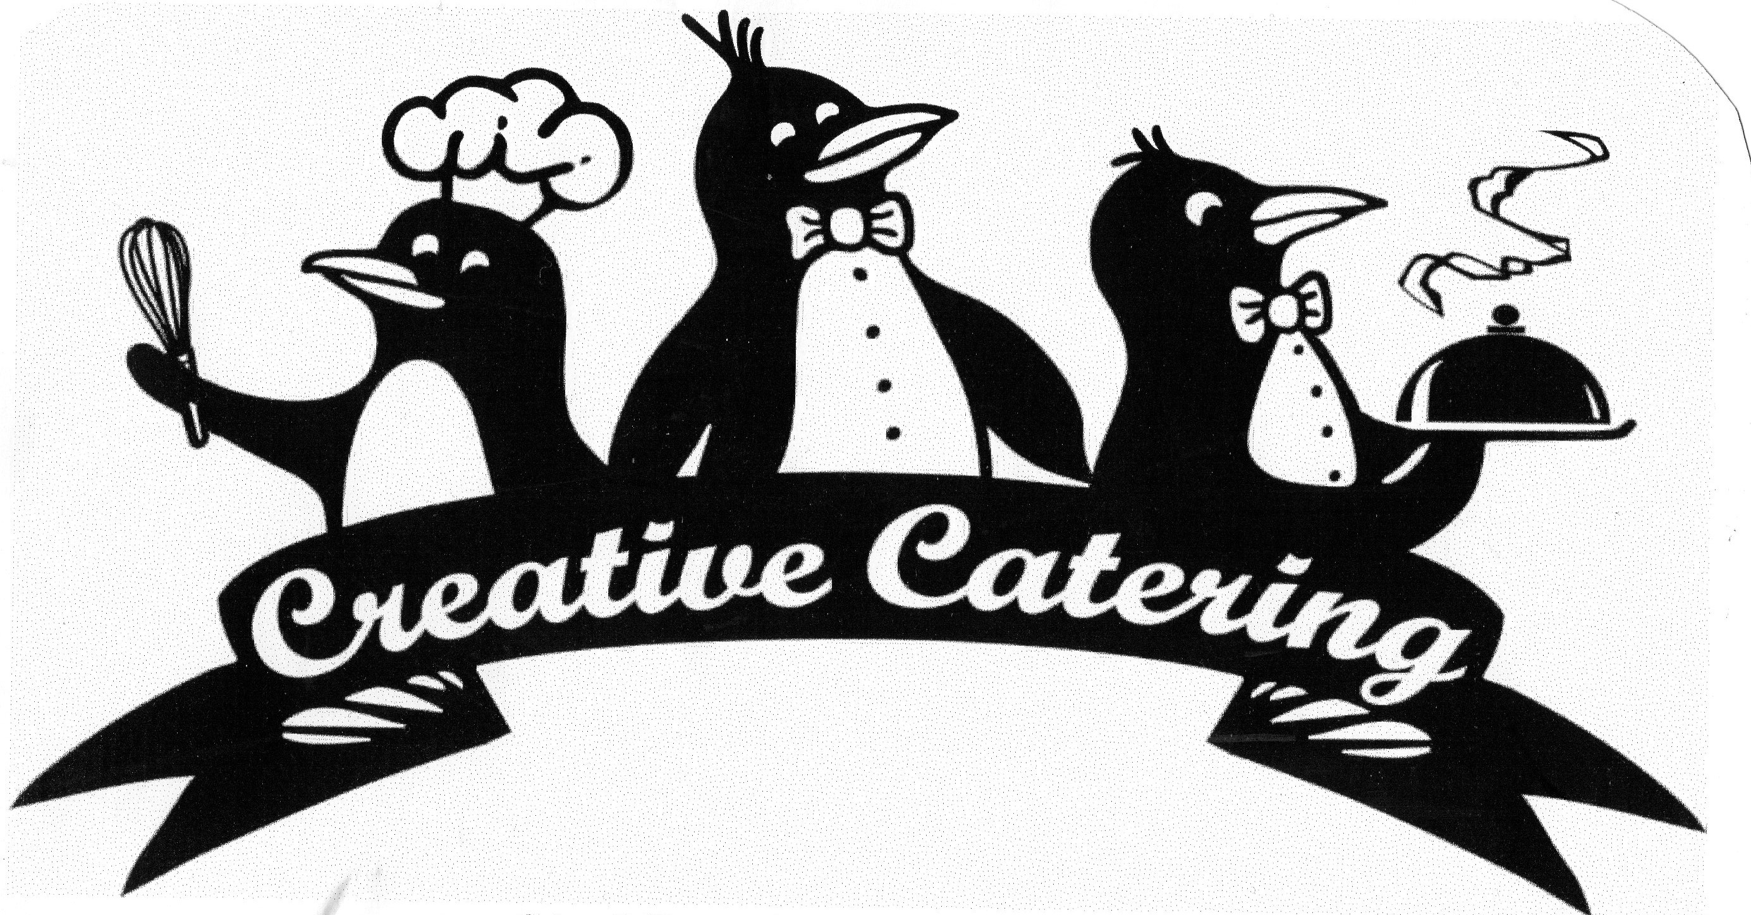

Serving New York since 1988
We are a Full Service Event Company

Ph: (315) 453-5555 www.CreativeCateringCNY.com CreativeCateringCNY@gmail.com

Wedding Dinner - Sample Menu

Stationary Hors d’oeuvres

FRESH VEGETABLE CRUDITE
Baby carrots, celery, broccoli, cauliflower, bell peppers, grape tomatoes, cucumber & extra sugar snap peas
With Ranch & Creamy Blue Cheese Dip

LOCAL NEW YORK CHEESE BOARD
With Yanceys Fancy XXX Sharp NY Cheddar blocks, surrounded Hot Pepper Cheese Curds
Plus gorgonzola, Brie & Provolone
Garnished with red & green grapes,
Accompanied with assorted crackers

ROASTED RED PEPPER HUMUS
Soft pita points

ASSORTED OLIVES
Kalamata, almond & pepper stuffed green olives, Sicilian with crushed red pepper
& California black olives garnished with roasted garlic cloves

Passed Hors d’oeuvres

MINI MARYLAND CRAB CAKES
With roasted pepper & horseradish aioli

ASIAGO & ASPARAGUS PHYLLO

GORGONZOLA STUFFED MEDJOOL DATES
Garnished with roasted almond & balsamic strawberry

Serving New York since 1988
We are a Full Service Event Company

Ph: (315) 453-5555 www.CreativeCateringCNY.com CreativeCateringCNY@gmail.com

Black Tie Farm To Table Buffet

Plated Salad
Summer Harvest Salad
Organic baby greens & romaine
Our own heirloom marinated tomatoes
English cukes, pickled red onions
Roasted garlic baguette crouton
Balsamic vinaigrette

Bread Basket
Fresh Country Breads & Rolls
New York Butter

Hard wood Grilled Sirloin of Beef
Tender Marinated Peppered Sirloin
Chef Carved, served Medium-Rare
Over Craft Beer fortified Au jus
English Horseradish sauce

Apple wood Grilled Chicken (boneless breasts)
Lemon Herb & Zested Local Honey brushed
Grilled lemon garnish

CLASSIC POLENTA
Sliced, Olive Oil brushed, & Grilled
With Vegan Basil Pesto
Parmesan on the side

GRILLED SALT POTATO SALAD (room temp)
Halved baby potatoes, poached, & torch scorched
EVOO, Agave, Cider vinegar, diced celery, scallion

TUSCAN GRILLED VEGETABLES
Room temp Red wine vinaigrette marinated grilled local zucchini, summer squash
Bell peppers, mushrooms & eggplant

Dessert

FRESH FILLED RICOTTA CANOLI
Creamy Italian Ricotta with a touch of semi sweet chocolate
Dusted with powdered sugar

FRESH STRAWBERRIES
Garnished with blueberries & fresh lemon
Turbinado Sugar served on the side
HAND WHIPPED BOURBON VANILLA HEAVY CREAM

