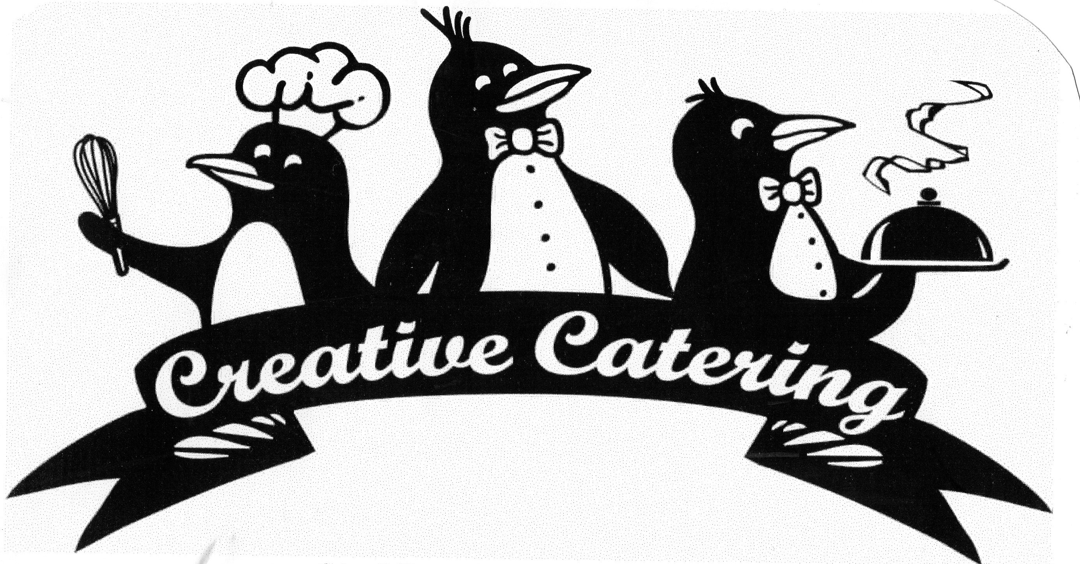

Serving New York since 1988
We are a Full Service Event Company

Ph: (315) 453-5555 www.CreativeCateringCNY.com CreativeCateringCNY@gmail.com

New York Comfort - Sample Menu

Stationary Appetizers

LOCAL NY CHEESE FROM LIVELY RUN DAIRY
Lake Effect Cheddar (cow), Finger Lakes Gold (goat)
& Cayuga Blue (goat)
Garnished with red & green grapes
Accompanied with crackers

CHARCUTERIE DISPLAY
Summer Sausage, Cappicola, thick sliced Margarita Pepperoni
Hofmann Ring Bologna, Hard & Genoa Salami
Sliced baguettes

OUR SIGNATURE CREAMY SPINACH, CHEESE & ARTICHOKE DIP
Served with tortilla chips

PASSED CHILLED SHRIMP
With zesty cocktail sauce ~ Lemon garnish

Buffet

SLOW SMOKED PASTURE RAISED PIG
Pig garnished with kale, apple or pepper in mouth

Accompanied with our home made BBQ Sauces
Beaver BBQ, Buffalo Bee Sting & Hurtin’ Ass

SWEET & SPICY MEMPHIS SLAW
Green & red cabbage, carrots, onions & red peppers
Sweet with a little heat

FRESH BAKERY ROLLS

DOUBLE DEE’S BEER CAN CHICKEN

HARVEST SALAD
Mesclun Mix & Baby Spinach
Tart Granny Smiths, Golden Raisins
& Sharp NY Cheddar (or other cheese)
Toasted Sunflower Seeds - Cider Vinaigrette

TOMATO & CUCUMBER SALAD
In our Red Wine Vinaigrette

GRANDMA’S MAC - n – CHEESE
Creamy with Land O’ Lakes American
Yancey’s Fancy XXX Sharp Cheddar & Parmigiano-Reggiano
French Fried Onion Crust

SALT POTATOES HOW YOU LIKE THEM (Cut in half)
Choice of Traditional Butter, Kickin’ Cajun or Garlic Basil Butter

“PULL MY FINGER” BBQ BAKED BEANS

MAPLE & BROWN SUGAR BRULEED CORN BREAD
As we served at The James Beard House
Watch our Cornbread Video

